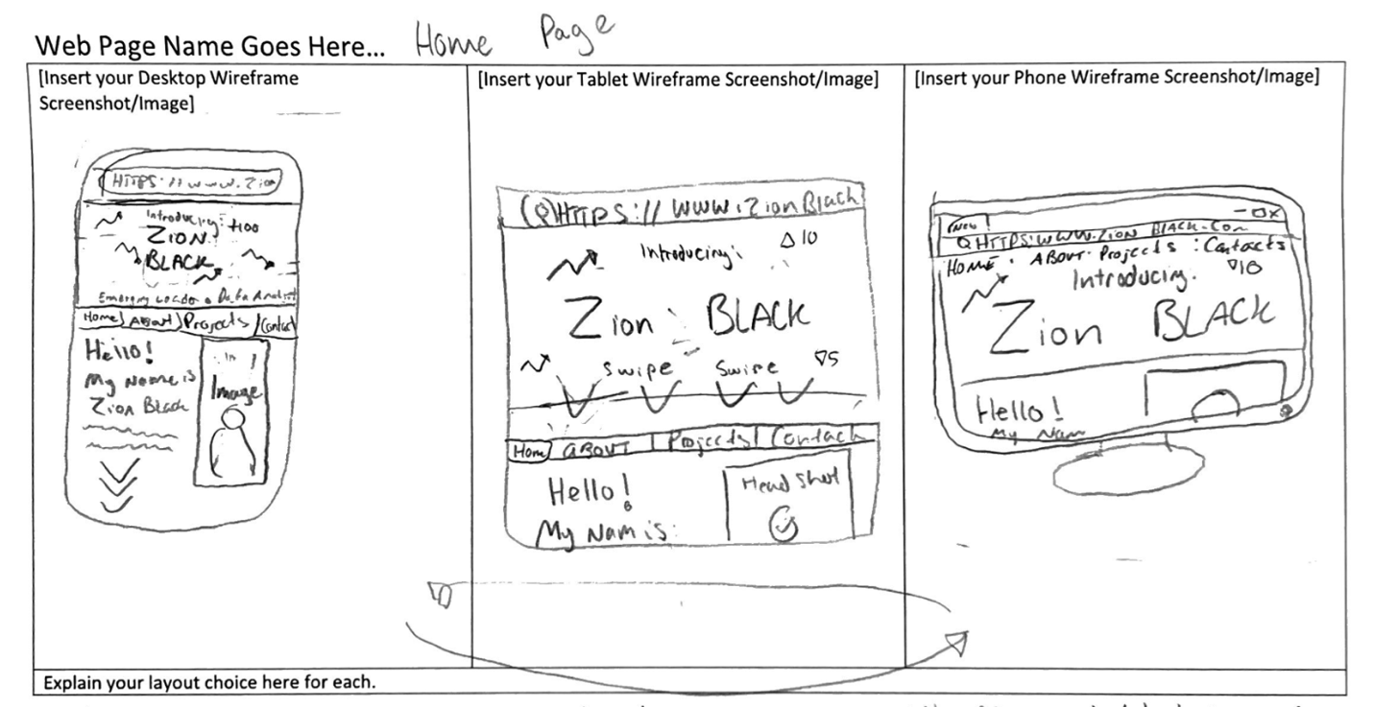

HexCodes:

|  |  |  |
| --- | --- | --- |
| **Egyptian Blue Background : #1434A4**  **Font Color: White #FFFFFF**  **Arrows/Navigation Bars: Cream #FFFDD0**  Fonts:  **Open Sans**  Content Inventory:  - “Introducing- Zion Joseph Black. An emerging leader in data analytics and business social media strategy.” “Welcome to Zion Black’s professional page! This website contains an in-depth look at some of the many projects and proposals I have tastefully curated throughout my career as a college data analyst and social media personality. These projects highlight the curiosity and courage it takes to question the status quo understanding of how things work and provide examples of the advancements that my expertise will bring to your team.”  **\*Including Headshot Getting Taken this Week**   |  | | --- | |  |  |  | | --- | |  | |

HexCodes:

**Egyptian Blue Background : #1434A4**

**Font Color: White #FFFFFF**

**Arrows/Navigation Bars: Cream #FFFDD0**

Fonts:

Open Sans

Content Inventory:

1. [Watch my Powtoon: About Me Video Template](https://www.powtoon.com/s/efDL0Of0BjY/1/m/s)
   1. I am Zion Joseph Black a second-year scholar at the University of Missouri-Columbia studying Economics on a full-ride scholarship. Coming from the home of the Kentucky Derby, Muhammed Ali, and Bluegrass music; my old Kentucky Home, of Louisville, KY, made the need to be 'The Greatest' my goal from a young age. Since moving to college and being on campus I have honed my skills and acumen to make myself into a stand-out student on a campus of over 30,000. I have achieved this through building reliable interpersonal relationships with students and faculty from all walks of life which have refined my worldview and bettered my problem-solving abilities by giving me a fresh perspective to approach age-old challenges without reinventing the wheel. My goal at college has been to inspire other students who look like me to step out of their comfort zone and reach for the stars by hosting professional etiquette workshops and networking opportunities for first and second-generation college students to help them get a leg up on their careers. As I continue to shoot for the moon and reach for the stars I am sure not to forget those at basecamp who helped me all along the way.

HexCodes:

**Egyptian Blue Background : #1434A4**

**Font Color: White #FFFFFF**

**Arrows/Navigation Bars: Cream #FFFDD0**

Font:

Open Sans

Content Inventory:

**University of Missouri- Fraternity and Sorority Life Columbia, MO**

I played a pivotal role in the development and execution of educational programs and workshops for fraternity and sorority members. These initiatives led to a 25% increase in attendance at educational events, and post-event surveys indicated a 95% satisfaction rate among participants, demonstrating the effectiveness or our educational efforts in fostering personal and leadership development withing the Greek community.

**Springfield-Greene County Park Board | River Cut Golf Course Springfield, MO**

Proficiently oversaw wondering and in-clubhouse concessions sales at River Cut Golf Course, delivering a 95% customer satisfaction rate, a 25% increase in service utilization, and a 15% reduction in response time by implementing efficient processes, personalized recommendations, and prompt issue resolution.

**Black Jack Sneakers (Galactic Commerce Authority LLC.)**

Successfully established and expanded a sneaker concierge service, achieving rapid growth and generating over $10,000 in revenue within the first year. Implemented effective marketing strategies resulting in a 200% increase in customer base, maintained a customer retention rate of 80%, and achieved an average customer rating of 4.9 out of 5 for service satisfaction.

**Brothers With Books** Spr. 2022

Initiated and organized a community event where African American students at Parkview High School served as reading mentors, collectively reaching out to over 300 students at surrounding elementary schools. This program fostered a love for reading, resulting in a 15% improvement in reading comprehension scores among participating elementary students and receiving positive feedback from teachers, parents, and the community."

**DecidED X Parkview High School College Affordability Collaboration** 2021-2022

Facilitated a strategic collaboration between Parkview Leadership School and DecidEd, a non-profit organization dedicated to college affordability, to provide comprehensive education on college affordability for high school students. Through this partnership, we reached and educated over 500 students, resulting in a 30% increase in student's knowledge and awareness of financial aid options, scholarships, and budgeting techniques to afford higher education.

HexCodes:

**Egyptian Blue Background : #1434A4**

**Font Color: White #FFFFFF**

**Arrows/Navigation Bars: Cream #FFFDD0**

Font:

Open Sans

Content Inventory:

My collegiate career as a student has been defined by several side hustles and my pursuit of becoming the best which has driven me to not bog myself down with perfectionism but accept the challenge of rigidity. This philosophy started with Black Jack Sneakers which taught me how to develop market expertise and how to act on perform analysis based on trends. This was realized by the rise and fall of the sneaker reselling sub-culture and side hustle that caused a lot of havoc during the pandemic. Black Jack Sneakers taught me that popularity is more than just vanity metrics and that something doesn’t have to be on the front page to have massive market value. Black Jack Sneakers was a clever way to get around my mother’s rules about balancing employment and school, during a time when having the extra couple of dollars to go out with friends made all the difference.

The skills I gained as a Sneaker Reseller/Concierge developed advanced communication and selling skills which set me apart as a Sales Representative at River Cut Gold Course, also known as a Bev Cart Boy. My skills in quick sales interactions were first impressions that made the difference between driving around hopelessly in hot weather and the cool relief of a crisp dollar bill. This role allowed me to develop the skills to talk to anyone from a wide range of cultural, regional, and socio-economic backgrounds and create a passion for people. These skills translated really well into my role as a Fraternity and Sorority Life Ambassador where I’d have to navigate a wider array of backgrounds in a professional and academic setting.

Working in a fraternity and sorority life at the University of Missouri, where over 25% of the student population is involved in fraternity and sorority life is an impactful role that puts me in the same rooms as change makers around campus. In a new environment where first impressions mattered, however, creating long-term relationships goes a whole lot further. Beyond talking to members of other fraternities, sororities, clubs, and faculty I also had to talk to prospective students and their parents who had their fair share of concerns. This role instilled a lot of self-confidence and the charisma that comes with it, allowing me to maneuver masterfully through professional spaces with bureaucratic processes and chains of command.

All of these roles came to a paramount in my role as a Loan Specialist at Veterans United Home Loans (NMLS #1907)( *NMLS ID#2604696)* where I would make ‘warm’ calls to potential home buyers to sell them on financing their home purchase with Veterans United. When following up on a lead very limited information was known, typically limited to: name, current address, phone number, and veteran status. However, information wasn’t always accurate and way to narrow to come up with a sure-fire sales pitch to their demographic in the 10 seconds the phone was ringing. This taught me how to sense the tone of a conversation and use murky information to build an accurate customer profile without knowing all of the information. Something that makes Veterans United stand out is our very human approach to the home-buying process and how personal we keep it, taking notes on buyer interest, life events, and even family structure to tailor the experience to their lives. These roles have all come together to make me a holistic, well-rounded analyst.

HexCodes:

**Egyptian Blue Background : #1434A4**

**Font Color: White #FFFFFF**

**Arrows/Navigation Bars: Cream #FFFDD0**

Fonts: **Open Sans**

Content Inventory:

Email: Zjblac01@gmail.com

Phone:5029311193

Linkedin: <https://www.linkedin.com/in/zion-black-99a2a4187/>